EQUALITY AND DIVERSITY
Name of the Student
Name of the University
Author Note
Table of Contents

Introduction 2
Learning needs and characteristics specific to the child 3
Critical analysis of Good Practice 5
Conclusion 8
References 10
Appendix 12
Roxanne’s Pot of Gold showing her proficiency in addition and her knowledge of numbers from 0 to 5 12
Backward counting and her knowledge of numbers from 1 to 20 13
Subtraction and her knowledge of numbers from 1 to 10 14
Usage of Visual Learning approach 15
Roxanne’s knowledge of numbers from 1 to 40 16

Introduction
The intellect, areas of interest and the method of studying differs hence the educational requirements of each children is different. It thus can be expected of all efficient to justifiably take care of the specific and the special needs of the children who enter their student life. In this report the focus of the discussion shall be to provide a critical analysis of the special educational requirements of a chosen child (Kilkenny 2018). The topics to be discussed in this particular report shall be focusing on the learning needs and characteristics specific to the child based on the behavioural predispositions of the chosen child and also a critical analysis of what constitutes a Good Practice.
The chosen child who is of Romanian origin has the learning characteristic of English as an Additional Language. She has shown signs of having extremely low level of self esteem and she also lacks confidence in taking part in the classroom activities. The chosen child also has shown signs of being quite esoteric as she hardly mingles with other children. The boy with whom she mingles is of Romanian origin as well. Both during class hours an also during break times she sits close to him.
On the basis of adjudging the behavioural predisposition of the child, the learning approaches that have been found to be appropriate are Hands On and Visual Learning approaches. It has been observed that the girl is fascinated by colours and she also takes interest in mathematics, on the basis of the Mathematics sessions and English session that has been done along with her. The Mathematics sessions that have been taken along with her shall be provided at the section devoted to the appendix as an evidential reference to the exercises that has been done with the chosen child.

Learning needs and characteristics specific to the child
In this part of the report the focus of the discussion shall be upon the identified learning requirements, issues and the educational approach that has been implemented upon the chosen child
The Specific Educational Need that the chosen child named Roxanne needs is that of English as an Additional Language, and the learning issues that she faces are lack of self esteem and lack of self esteem in classroom activities and also it is affecting her socialization skills. The Specific Educational Need and the learning issues that Roxanne faces shall be discussed in relation to each other since the Specific Educational Need of English as an Additional Language is a necessity in her case and through it the linguistic barriers which she faces has been sought to be solved. Roxanne is a child who is of Romanian origin and naturally, English is not her first language. She has immigrated to the United Kingdom where Romanian is not a very commonly spoken language and her lack of knowledge of English debars her from communicating with other children in her study group. Since she is unable to express herself adequately in English she suffers from a sense of low esteem and that is also reflected in her lack of enthusiasm in participating in the classroom activities. It is natural for all human beings to distance oneself from collectivities or activities within which one finds difficult to communicate. Roxanne by virtue of her inability to communicate in English thus found it extremely difficult to make herself feel included in the class to which she belonged (Boggis 2016).
This specific condition on part of Roxanne to not be able to communicate, having low self esteem and lacking confidence is an educational need not a health oriented need as she has such has no mental issue which prevents her from socialization. With regard to the socialization pattern of Roxanne it becomes apparent that she is selectively social and she only mingles with a ten year bold in her class as he is of Romanian origin as well which makes it apparent that she is not averse to the idea of being social with people around her. Rather the issue is that she needs people with whom she could communicate without much inhibition and no communication barriers in linguistic terms. Thus the Specific Educational Need that the chosen child named Roxanne needs is that of English as an Additional Language and does not include any health care plan since the condition faced by Roxanne is purely a matter of linguistic inconvenience. Roxanne has as such has not been diagnosed with any learning difficulty and she has shown quite impressive results with regard to her mathematics session which has been taken with her. Roxanne has shown quite impressive results with regard to her mathematics lesson which also shows that her comprehension skills are quite impressive and she is also quite adept with regard to her skills with numbers. The evidential references to her mathematical skills shall be provided at the section dealing with the appendix. Mathematics lesson have been possible to be taken with her and very few English lessons given her lack of expertise in English language (Middleton and Kay 2019).
Five images of the mathematical lessons taken with which have been affixed at the section dealing with her number skills through Numicon consists of Roxanne’s Pot of Gold showing her proficiency in addition and her knowledge of numbers from 0 to 5; Backward counting and her knowledge of numbers from 1 to 20; Subtraction and her knowledge of numbers from 1 to 10; Usage of Visual Learning approach through the exercise of counting frogs and Roxanne’s knowledge of numbers from 1 to 40 exhibited through her skills in addition. Roxanne has excelled in these exercises and the results tend to show that her skills in mathematics, specifically pertaining to the addition, subtraction, counting and her knowledge with regard to numbers on an overall basis is quite impressive. Hence with more guidance she can definitely excel in her English communication and overall socialization skills.
On the basis of adjudging her Special Educational Needs, the Hands On and the Visual Learning approaches have been employed. The mathematics lessons which have been taken with Roxanne are inspired by the learning approaches of the Hands On and the Visual Learning. With regard to the learning approach of Hands On it can be said that it emphasizes more on learning by means of actually attempting something rather than simply listening to the tutor delivering the lectures in the classroom. Very closely related to the learning approach of Hands on is the learning approach of Visual Learning which emphasizes that learning can be enhanced by means of the visual aspect. In this process of learning the usage of visual aspect such as diagrams, charts, pictures are utilized with the intention of enhancing learning by means of presenting a representation of what the child is learning. In the case of Roxanne, with regard to the lessons on mathematics that has been taken with her shows that the usage of images has enhanced her skills in identifying and calculating numbers. The mathematical lessons taken with Roxanne have utilized the usage of images of animals, flowers, objects in order to ensure that her comprehension with regard to the activity provided dealing with numbers is not compromised as a result of her lack of ability in English language comprehension (Higbee and Sellers 2017).

Critical analysis of Good Practice
The learning approaches of the Hands On and the Visual Learning which have been employed in the case of Roxanne have been so done in order to ensure that the seven key principles of Good Practice be upheld. Good Practice in education refers to the adherence to the principles in the process of disseminating learning that benefit the child to the maximum possible level, both at an individual level and also at the level of a collectivity. The aim of the employment of the principles of Good Practice in the process of dissemination of the process of learning is so done with the view to ensure that the individual needs of the child is met and at the same time the child is also properly integrated into the collectivity effectively. In this particular part of the report the focus of the discussion shall be on a critical analysis of a wide range of activities and educational practices that shall be beneficial in aiding and analyzing the academic progress of a child with a critical undertone. The discussion shall be in relation to the case of the chosen child Roxanne.
Encouragement of close contact between the student and the tutor – With regard to the case of Roxanne it can be said that special attention on part of the tutor has been provided in order to make her feel as part of the class since she does not speak and communication problem could isolate her. Hence adequate steps have been taken to ensure that the child does not feel left out and activities which she cherishes are emphasized upon to ensure maximum amount of activeness on her part with the view to utilize her strengths and derive insights from it to help her grow out of her weaknesses (Nawroth et al. 2017).
Development of reciprocity and cooperation between the student and the tutor – With regard to this particular it can be said that the learning approaches of the Hands On and the Visual Learning have been employed. These two approaches have been employed in the case of Roxanne to ensure her inclusivity into the classroom environment since she suffered from a sense of low self esteem and low level of self confidence due to her non English linguistic background. Roxanne was of Romanian origin and due to the factor of linguistic convenience she only communicated with another Romanian boy. This drawback in her has been sought to be solved by means of employing the learning approaches mentioned in her case to aid the factor of inclusivity of the child and also the factor of close engagement with the teacher and the child at the same time (Venant et al. 2017).
Encouragement of active learning – This particular factor has been sought to be implemented by means of strengthening the already existing talents of the child and also to strengthen her weaknesses. The child Roxanne has shown signs of having a knack for mathematics which is her strength, which shall be ensured to be strengthened further. Her weakness involves her lack of expertise in communicating in English and her socialization skills which has been planned to be enhanced by the usage of visuals (Hall and Miro 2016).
Provision of prompt learning – On the basis of the mathematical exercises done with her it has been observed that the use of visuals dies winders in ensuring prompt learning on her part. Coupled with that, the factor of entering into her zone of comfort shall be beneficial for the purpose of ensuring prompt learning (Callanan and NatCen Social Research 2017).
Laying emphasis on the time factor – The time factor is indeed quite important especially with regard to the removal of the linguistic barrier or else she has be falling backwards compared to her other classmates. For that purpose the step of devoting more attention to her English learning has been planned out which is likely to benefit her. The faster Roxanne develops a considerable degree of proficiency in English, the better is it for her overall educational and personality oriented development (Knowles 2017).
Communication of high expectations to be met by the student – This particular point is extremely important as keeping high expectations on part of the teacher to be fulfilled by the student is a way of promoting inclusivity. Roxanne, as it has been mentioned that she keeps herself aloof, and in this situation the teacher is supposed to ensure that she is rendered with the feeling of inclusivity and that can happen through providing her a sense of belongingness (Callanan and NatCen Social Research 2017).
Respect for diversity – This is extremely an important step to be upheld by the teacher in order to ensure that the principle of inclusivity is upheld adequately. Roxanne being of Romanian origin and special educational needs makes it apparent that she contributes to the diversity of the classroom (Venant et al. 2017).
These are the steps which have been planned to uphold the principle of good practice in the case of Roxanne to help her out in her educational ventures.

Conclusion
In the previous sections the discussion has focused upon the issues faced by the chosen child Roxanne and the necessary steps that have been planned to be taken in order to enhance the weaknesses of the chosen child into her strength. The Specific Educational Need that the chosen child named Roxanne needs is that of English as an Additional Language, and the learning issues that she faces are lack of self esteem and lack of self esteem in classroom activities and also it is affecting her socialization skills. The Specific Educational Need that the chosen child named Roxanne needs is that of English as an Additional Language, and the learning issues that she faces are lack of self esteem and lack of self esteem in classroom activities and also it is affecting her socialization skills. This goes as far as the issues Roxanne faced and the solutions which have been employed in her case.
In this concluding section of the report the focus of the discussion shall be upon providing suggestions with regard to going about with the incorporation of the principle of Good Practice into the case of Roxanne. The most important issue that has been identified in the case of Roxanne is that the aspect of devoting attention to her mathematics has been adequately dealt with while not much exercise has been done with her in English which is her most important weakness. Hence it is being recommended that the principles of Good Practice be applied in the case of Roxanne to enhance her English linguistic skills which is a major impediment in her. As per the principle of Good Practice, the skills of Roxanne with regard to her mathematical skills can be used to channelize it into making her gain enough expertise in her English language proficiency and thereby also aid in her communication skills. The girl has show her expertise in her mathematics sessions which shows that she is quite proficient in academics and with more guidance she can gain the required expertise in her English language skills and thereby improve her communication skills more than ever before. The girl, Roxanne has enough potential and if she gets proper guidance she can excel in all fields. Roxanne as such is not unsociable by nature just that she finds it difficult to communicate with English speakers. Had she been unsociable by nature then she would have not socialized even with the boy belonging to her own ethnic background, of Romanian nationality. Hence it is expect that the girls Roxanne be provided with proper guidance from the teachers so that she could not just strengthen her weaknesses but also so that she could enhance her existing strengths.

References
Boggis, A., 2016. 22 Supporting inclusive practice in the Early Years. The Early Years Handbook for Students and Practitioners: An essential guide for the foundation degree and levels 4 and 5, p.343.
Callanan, M. and NatCen Social Research, 2017. Study of early education and development: Good practice in early education. London, UK: Department for Education.
Hall, A. and Miro, D., 2016. A study of student engagement in project‐based learning across multiple approaches to STEM education programs. School Science and Mathematics, 116(6), pp.310-319.
Higbee, T.S. and Sellers, T.P., 2017. Visual learning strategies to promote independence and appropriate social behavior. In Handbook of Social Skills and Autism Spectrum Disorder (pp. 241-256). Springer, Cham.
Kilkenny, K., 2018. Supporting Inclusive Practice and Ensuring Opportunity Is Equal For All. Support for learning, 33(1), pp.92-93.
Knowles, C., 2017. Closing the attainment gap in maths: a study of good practice in early years and primary settings. London: Fair Education Alliance. Available at: https://static1. squarespace. com/static/543e665de4b0fbb2b140b291, 58, p.1487596235907.
Middleton, T. and Kay, L., 2019. A Framework to consider the six dimensions of inclusive education: supporting practitioners to reduce school exclusion.
Nawroth, C., Prentice, P.M. and McElligott, A.G., 2017. Individual personality differences in goats predict their performance in visual learning and non-associative cognitive tasks. Behavioural processes, 134, pp.43-53.
Venant, R., Sharma, K., Dillenbourg, P., Vidal, P. and Broisin, J., 2017, June. A Study of Learners’ Behaviors in Hands-On Learning Situations and Their Correlation with Academic Performance. In International Conference on Artificial Intelligence in Education (pp. 570-573). Springer, Cham.

Appendix

Roxanne’s Pot of Gold showing her proficiency in addition and her knowledge of numbers from 0 to 5
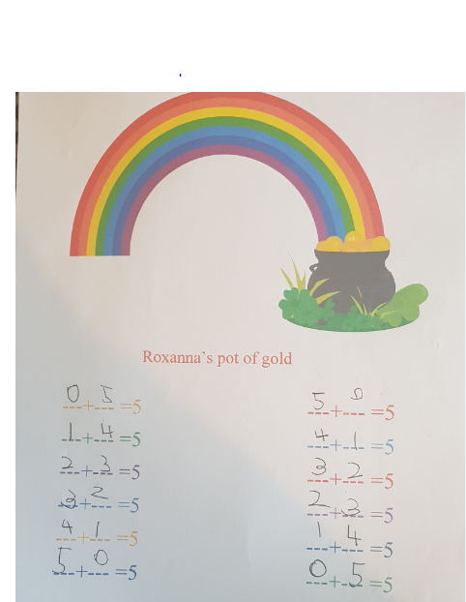

Backward counting and her knowledge of numbers from 1 to 20

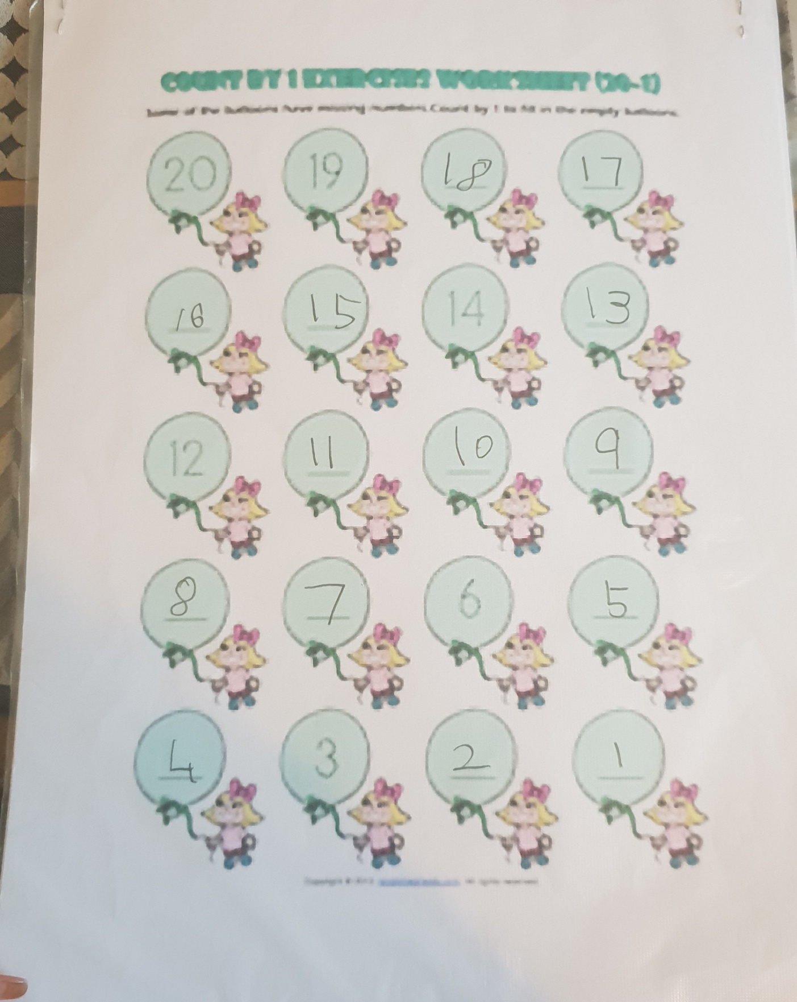

Subtraction and her knowledge of numbers from 1 to 10

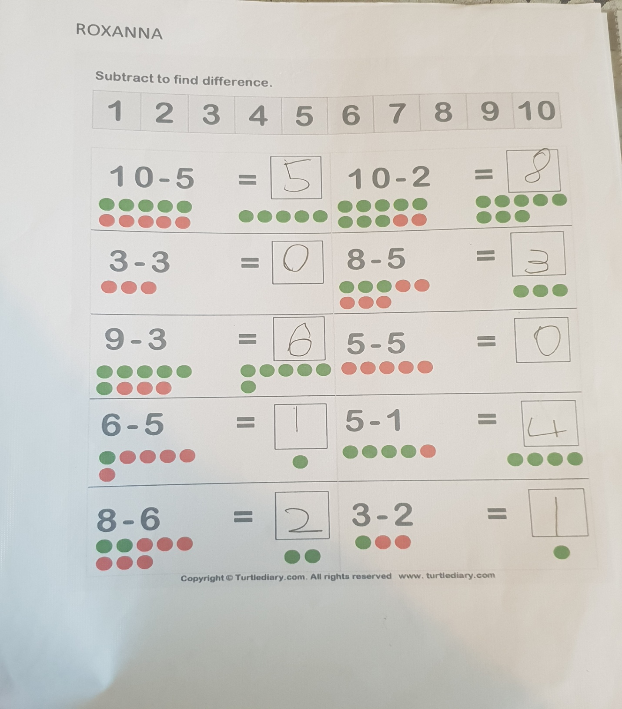

Usage of Visual Learning approach
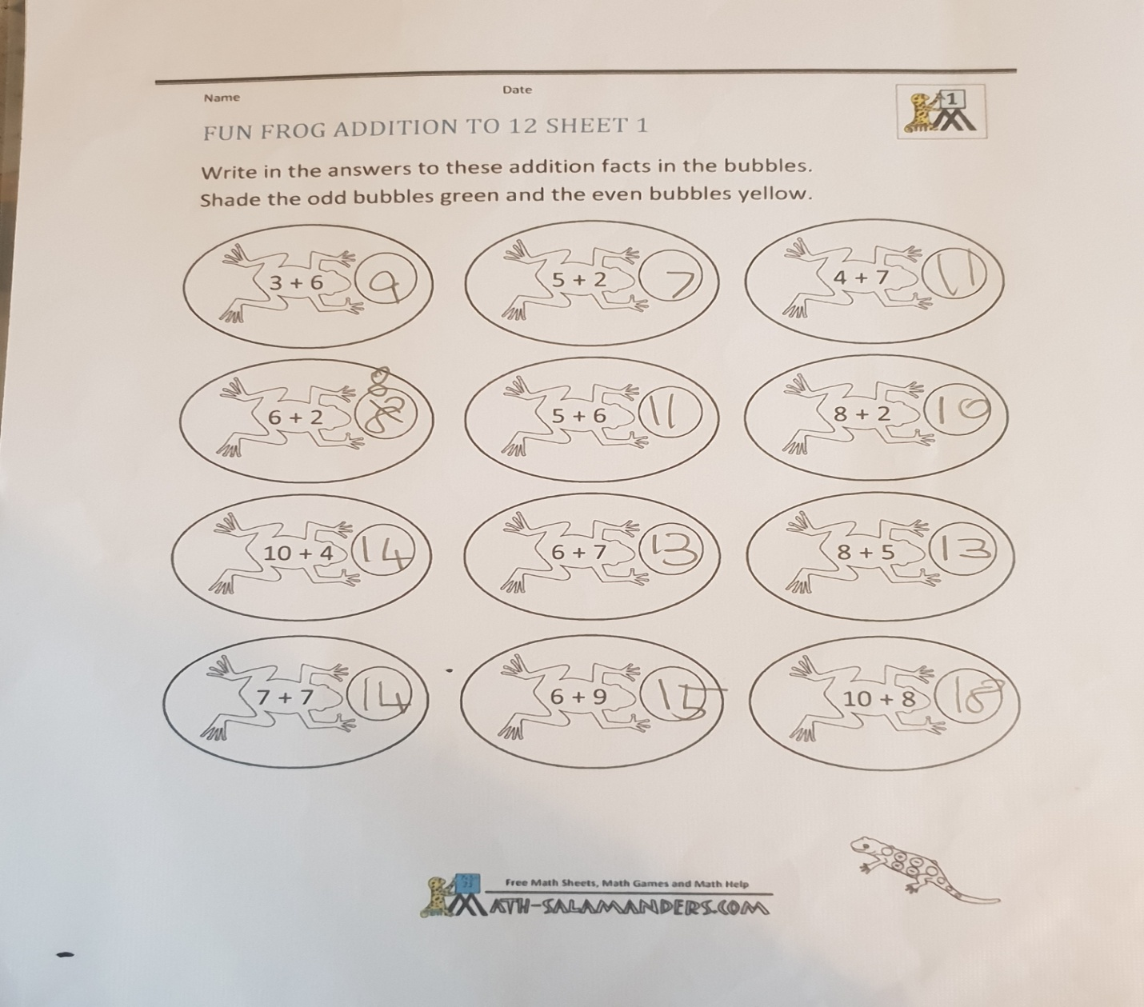

Roxanne’s knowledge of numbers from 1 to 40

